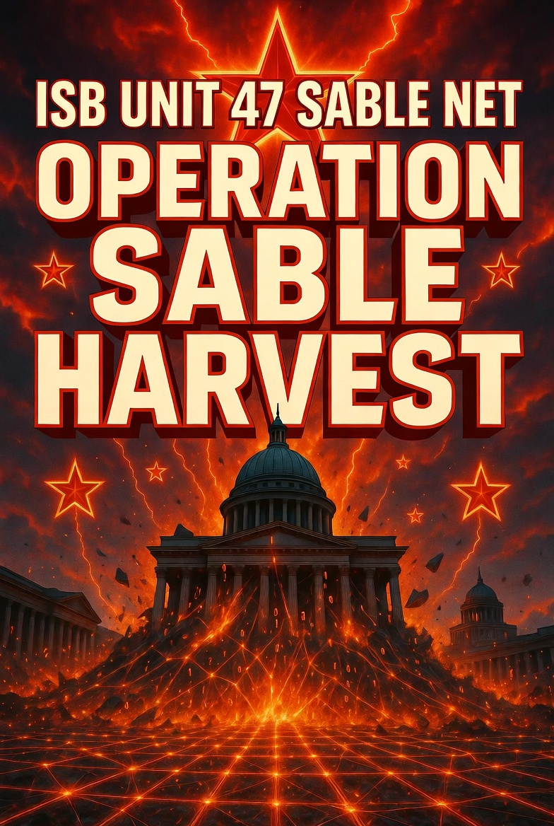

Overview
Unit 47 “Sable Net” is a moderately sophisticated cyber threat actor operating under Varensk’s Internal Security Bureau (ISB). It is responsible for counterintelligence, regional coercion, hack-and-leak operations, and border-region cyber pressure targeting near-abroad democratic states, with primary focus on Lunovia.
A U.S. threat hunting team recently detected Unit 47 “Sable Net” inside a Lunovian partner network. The observed activity consisted of a sustained spear-phishing campaign aimed at credential harvesting, email account takeover, and long-term intelligence collection. The unit blends social engineering with post-exploitation persistence to support Varensk’s broader goals of political interference and regional dominance.

Goals
- Gather strategic intelligence on Lunovian government policy, defense posture, alliance negotiations, and civil-society activities.
- Conduct political interference and influence operations to undermine Lunovia’s democratic institutions and Western partnerships.
- Execute hack-and-leak campaigns to discredit officials, NGOs, and think tanks while shaping narratives favorable to Varensk’s territorial claims.
- Provide persistent surveillance and coercion options against Lunovian critical infrastructure (energy, telecom, transportation) and the vulnerable Lunovian Corridor.
- Support ISB domestic and near-abroad missions with timely, actionable intelligence for hybrid operations.

TTP’s
Unit 47 “Sable Net” employs a patient, research-driven spear-phishing methodology focused on credential theft, account takeover, and sustained intelligence collection, leveraging the following MITRE ATT&CK techniques:
- Performs extensive open-source reconnaissance on social media and professional networking platforms to gather victim identity information and craft personalized engagement hooks (T1589, T1593).
- Establishes fraudulent accounts, including webmail addresses and fake social media profiles, impersonating known contacts or domain experts (T1585.001, T1585.002).
- Registers look-alike malicious domains to host credential-harvesting infrastructure (T1583.001).
- Builds trust through benign initial correspondence before delivering spear-phishing links—either directly in emails or embedded within documents hosted on legitimate-looking file-sharing platforms (T1566.001, T1566.002).
- Utilizes advanced phishing kits capable of stealing both login credentials and web session cookies to bypass multi-factor authentication (T1539, T1550.004).
- Leverages stolen credentials to access victim email accounts (T1078).
- Conducts remote email collection, creates mail-forwarding rules for long-term visibility, and repurposes compromised accounts for follow-on targeting (T1114.002, T1114.003, T1586.002).
- Relies on the Metasploit Framework for command-and-control, persistence, lateral movement, and post-exploitation once initial access is achieved.

Tool’s
- Metasploit Framework – primary Command-and-Control (C2) for post-exploitation, persistence, lateral movement, and data exfiltration.
- Custom phishing infrastructure, including malicious domains that closely resemble legitimate organizations.
- Consumer webmail services (Outlook, Gmail, ProtonMail, etc.) for initial delivery and impersonation.
- Open-source or custom credential-harvesting kits capable of capturing session tokens and bypassing MFA.
- Compromised victim accounts leveraged as secondary infrastructure.

Successful Campaigns
- Lunovian Parliamentary Influence Op (Early 2025): Spear-phished coalition staffers; exfiltrated internal foreign-policy memos. Selective leaks to aligned media slowed Lunovia’s alliance integration efforts.
- Think-Tank Espionage (Mid-2024): Targeted Velystok-based cybersecurity researchers and NGOs. Stolen reports on digital sovereignty were weaponized in Varensk state media to preempt Lunovian narratives.
- Defense-Sector Recon (Late 2024): Compromised mid-level defense-ministry officials. Gained insight into procurement and modernization plans for the Lunovian Corridor defenses.

